2021 JOINT CALL
ERA-NET Cofund
SusAn, FACCE ERA-GAS,
ICT-AGRI-FOOD and SusCrop

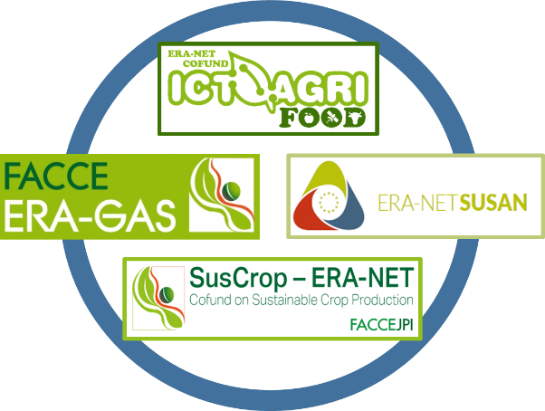

“Circularity in mixed crops and livestock farming systems with emphasis on climate change mitigation and adaptation”

CALL FOR PROPOSALS
Deadline for submission of full proposals:
May 26, 2021 (15:00 CEST)
Work plan template
published on March 30, 2021
Before uploading please delete this cover page and the red captions within the text, and convert the remaining document into PDF file format.
The document must not exceed the length of 20 DIN-A4 pages (Arial 11pt, line pitch at least 1.15, allowed file size: 5 MB, PDF file format). Uploading of more than 20 pages is blocked by the online submission system.
The work plan should clearly describe the individual work packages, tasks, deliverables and milestones of the project. The work plan must also include a Gantt-Chart.
The submission must be done online via https://www.suscrop.eu/2021-joint-call

WP 1 | Name of WP |  |  |  |  | Start Month: |  | End Month:
Partners involved
Person-Months
Aim of the WP (brief description of the objectives and interrelations with other WPs)

Description of tasks (clearly state who is doing what within the task description)
Text goes here.
Task 1.1: Title (Task leader, partners involved) - Duration : Month xy – Month yz
Task description goes here.
Task 1.2: Title (Task leader, partners involved) - Duration : Month xy – Month yz
Task description goes here.
Deliverables:
D1.1: Title (Month of delivery)
Description goes here.
D1.2: Title (Month of delivery)
Description goes here.
Milestones:
M1.1: Title (Month of delivery)
Description goes here.
M1.2: Title (Month of delivery)
Description goes here.
Risks and contingency (explain the main risks which could jeopardize the planned work in this WP, especially the completion of deliverables, and your plans to overcome them/adapt the work plan)
Description goes here.

WP 2 | Name of WP |  |  |  |  | Start Month: |  | End Month:
Partners involved
Person-Months
Aim of the WP (brief description of the objectives and interrelations with other WPs)

Description of tasks (clearly state who is doing what within the task description)
Text goes here.
Task 2.1: Title (Task leader, partners involved) - Duration : Month xy – Month yz
Task description goes here.
Task 2.2: Title (Task leader, partners involved) - Duration : Month xy – Month yz
Task description goes here.
Deliverables:
D2.1: Title (Month of delivery)
Description goes here.
D2.2: Title (Month of delivery)
Description goes here.
Milestones:
M2.1: Title (Month of delivery)
Description goes here.
M2.2: Title (Month of delivery)
Description goes here.
Risks and contingency (explain the main risks which could jeopardize the planned work in this WP, especially the completion of deliverables, and your plans to overcome them/adapt the work plan)
Description goes here.

To be continued with further WPs

Please do not forget to include a Gantt Chart in this document!

- End of template-

